|  |  |
| --- | --- |
| **Ex. No:** | **WEB TECH MODEL LAB** |
| **2-11-23** |

**Aim:** To create an app using React with Components, Rendering, and Data Sharing.

**Program:**

Microsoft login page:

App.js

|  |
| --- |
| import Form from "./components/Form"; import "./styles.css";  export default function App() { return (  <div className="">  <Form />  </div>  );  } |

Index.js

|  |
| --- |
| import { StrictMode } from "react"; import { createRoot } from "react-dom/client";  import App from "./App";  const rootElement = document.getElementById("root"); const root = createRoot(rootElement);  root.render( <StrictMode>  <App />  </StrictMode>  ); |

Styles.css

body { background-color: lightgray;

|  |
| --- |
| }  .form { height: 400px; width: 600px; margin: 0 auto; margin-top: 150px; background-color: white; padding: 10px;  }    .heading { margin-top: 10px; color: gray; margin-left: 10px;  }  .top { padding-left: 10px; display: flex;  } img {  height: 40px;  }  .sub { margin-left: 10px; color: black;  } input { width: 90%; margin-left: 10px; padding: 10px;  }  .mid { display: flex; align-items: center; gap: 10px; margin-top: 10px;  }    .para1, .link2 { margin-left: 10px;  } |
| a { text-decoration: none; color: blue;  }    .bottom {  margin-top: 20px;  }    .buttons { float: right; margin-top: 20px; padding: 10px;  } button { height: 40px; width: 80px; margin-left: 10px; border: none; cursor: pointer;  } |

Form.js

|  |
| --- |
| import Button from "./Button";  function Logo({ title }) { return (  <> <img alt="logo" src="https://upload.wikimedia.org/wikipedia/commons/thumb/4/44/Microso ft_logo.svg/2048px-Microsoft_logo.svg.png" />  <h3 className="heading">{title}</h3>  </>  );  } function Form() { return (  <div className="form">  <div className="top">  <Logo title="Microsoft" />  </div>  <h2 className="sub">Sign In</h2>  <input placeholder="Email,phone or skype" /> |
| <div className="mid">  <p className="para1">No account?</p>  <a href="/">Create One!</a>  </div>  <a className="link2" href="/">  Can't access your account?  </a>  <div className="bottom">  <a className="link2" href="/">  Sign in with Windows Hello or a Security Key ?  </a>  </div>  <div className="buttons">  <Button bgcolor="lightgray" title="Back" color="" />  <Button bgcolor="#0067b8" title="Next" color="white" />  </div>  </div>  );  } export default Form; |

**Output:**

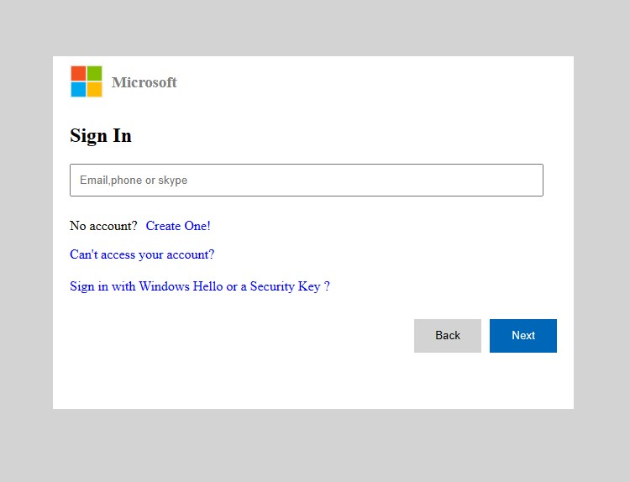

**Result:** Therefore, we've successfully implemented